** **

**Scottish Paediatric**

**Cardiac Service**

**ECHOCARDIOGRAPHY IN**

**PAEDIATRIC CONGENITAL HEART DISEASE**

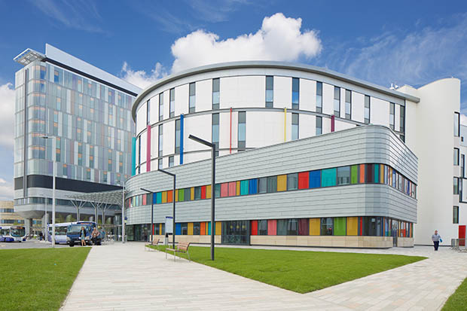

***Royal Hospital for Children & Queen Elizabeth University Hospital, Glasgow***

[**www.paediatricecho.co.uk**](http://www.paediatricecho.co.uk)

**Overview**

The course provides clinically relevant lectures, case studies and hands-on small group tutorial on performing echocardiography with participating volunteer paediatric patients, delivered by consultant paediatric cardiologists, consultant neonatologist with expertise in cardiology and advanced cardiac physiologists with ESC accreditation in congenital heart disease echocardiography. Those with a basic level of experience in Echocardiography will find it much easier to follow. Course lecture handouts will be provided via the course website: http://www.paediatricecho.co.uk/. The course fills quickly so early applications are advised.

***Day 1***

***Tuesday 17th June, 2025***

**Venue: Teaching and Learning Centre**

**08.45 – 09.00** **Registration**

**Session 1 – Chair: Georgios Meridis**

**09.00 – 09.10**  Maria Ilina Welcome and introduction

**09.10 – 10:00** Stuart Lilley Physics of the ultrasound

**10.00 – 11:00** Brodie Knight Normal anatomy, segmental analysis &

morphology

**11:00 – 11.15**  **~ Tea/Coffee ~**

**Session 2 – Chair: Maria Ilina**

**11.15 – 11:45** Lynsey McIntyre Normal study and reporting

**11.45 – 12:30** Georgios Meridis Assessment of ventricular function

Cardiomyopathies

**12.30 – 13:00** Georgios Meridis Congenital anomalies of coronary arteries

**13:00 – 14:00 ~ Lunch ~**

**Session 3 – Chair TBC**

**14:00 – 14.45** Emma Finlay VSD, AVSD

**14.45 – 15.30** Anne Marie Heuchan Echocardiography in Neonatology

**15:30 - 15:45 ~ Tea/coffee ~**

**Session 4 – Chair TBC**

**15.45 – 16.40** Maria Ilina Right-sided obstructive lesions

**16.40 – 17.30** Georgios Meridis Left-sided obstructive lesions

***Day 2***

***Wednesday 18th June, 2025***

**Venue: Teaching and Learning Centre**

**Session 1 – Chair TBC**

**9.00 – 10:00** Lindsey Hunter Fetal Echocardiography

**10:00 – 11:00** Lesley ArmourTransposition of the great arteries

and double outlet right ventricle

**11:00 – 11:15 ~ Tea/coffee ~**

**Session 2 – Chair TBC**

**11:15 – 12:00** Nicholas Martin Atrial septal defect, total and partial anomalous

venous drainage

**12:00 – 13:00** Lesley Armour Rare and complex biventricular: CAT,

Ebstein anomaly, isomerism, criss-cross heart

Uhl anomaly, giant left atrium…

**13:00 – 13:45 ~ Lunch ~**

**Session 3 – Chair TBC**

**13:45 – 14:45** Ben Smith Echocardiography in postoperative follow up

**14:45 – 15:30** Pankaj Gupta Aortic arch anomalies and PDA

**15:30 - 15:45 ~ Tea/coffee ~**

**Session 4 – Chair: Pankaj Gupta**

**15:45 – 16.30** Maria Ilina Univentricular heart

**16:30 – 17:30** Stuart Lilley Quiz

**19.30** **Course Dinner: (venue TBC)**

***Day 3***

***Thursday 19th June, 2025***

**Venue: Teaching and Learning Centre, Clinical Skills Area**

**Practical Studies:**

**09:00 – 10:45**  M-mode, 2D echo and Doppler. Image acquisition and optimisation, normal study

**10:45 – 11:00 ~ Tea/coffee ~**

**11:00 – 13:00** Normal study, “Simple” congenital lesions (ASD, VSD, AS, PS, PDA)

HeartWorks

**13:00 – 13:45 ~ Lunch ~**

**13:45 – 15:30** “Simple” (ASD, VSD, AS, PS, PDA) and “moderate” (ToF, TGA) congenital lesions

HeartWorks

**15:30 – 15:50** **~ Tea/coffee ~**

**15:50 – 17:30** “Complex” (DORV, complex TGA, common arterial trunk, PA/VSD, PA/IVS, CCTGA, Ebstein anomaly) biventricular and univentricular congenital cardiac lesions

3D models

***Day 4***

***Friday 20th April, 2024***

**Venue: Teaching and Learning Centre, Clinical Skills Area**

**Practical studies:**

**10.00 –12:30** Simple, Moderate, Complex biventricular and univentricular hearts

HeartWorks

3D models

**Please complete and hand in course evaluation forms, then receive password to download handouts**

**~ End of Course ~**

**COURSE FACULTY**

**Ms Lesley Armour, Paediatric Cardiac Physiologist**

**RHC Glasgow**

**Ms Emma Finlay, Lead Cardiac Physiologist**

**RHC Glasgow**

**Dr Pankaj Gupta, Consultant Paediatric Cardiologist**

**RHC Glasgow**

**Dr Anne-Marie Heuchan, Consultant Neonatologist**

**RHC Glasgow**

**Dr Lindsey Hunter, Consultant Paediatric Cardiologist**

**RHC Glasgow**

**Dr Maria Ilina, Consultant Paediatric Cardiologist**

**RHC Glasgow**

**Dr Brodie Knight, Consultant Paediatric Cardiologist**

**RHC Glasgow**

**Mr Stuart Lilley, Consultant Cardiac Physiologist**

**RHCYP Edinburgh**

**Mr Nicholas Martin, Cardiac Physiologist**

**RHC Glasgow**

**Ms Lynsey McIntyre, Senior Cardiac Physiologist**

**RHC Glasgow**

**Dr Georgios Meridis**

**Consultant Paediatric Cardiologist**

**RHCYP Edinburgh**

**Dr Benjamin Smith, Consultant Paediatric Cardiologist**

**RHC Glasgow**

**Course Co-Directors: Lynsey McIntyre, Maria Ilina**

**Course Administrator: Michelle Drum, Senior Medical Secretary**

**Project Manager, Glasgow Children’s Hospital Charity**

**Course website** [**www.paediatricecho.co.uk**](http://www.paediatricecho.co.uk)

**This course would not be possible without the generous support from:**

**GE Healthcare**