**Tender: Website for Project Innovation**

**July 18th 2023**

1. **Overview**

Project Innovation is a major new initiative supported by the Glasgow Children’s Hospital Charity. Our aim it to be a world-leading centre for children’s health innovation, based in the heart of Glasgow, but with global reach and impact.

**Our aims are to:**

* Transform children’s health, care, and lives
* Create new healthy and sustainable models of care
* Drive successful partnerships within the life science sector

**Our strategy for delivery:**

* Identify key priority areas for innovation in Children’s and Women’s Health
* Collaborate with innovators, clinicians, and NHS leadership to develop a roadmap to success
* Connect clinical teams, innovators, and funders
* Provide “end-to-end” clinical project support

**Who benefits**

* **Children:** we will improve their health and care
* **Families:** we will support them and improve health and well being
* **NHS Staff:** improve experience; efficiency; skills development; staff health and wellbeing
* **NHS leadership:** delivery of local and national priorities; reputational benefits; attract and retain staff
* **The Government:** delivery of projects that are aligned to our defined outcomes will have a positive economic impact

Each of our projects will be carefully selected through robust investigation and research, both clinically and commercially. Our team will provide a detailed impact study of the expected project outcomes to ensure that they align to our objectives and that they will have a positive impact.

We work in conjunction with the Glasgow Children’s Hospital Charity, who raise money to ensure that the babies, children, and young people treated at the Royal Hospital for Children receive the best possible care.

We are looking for a new website for the launch of our company which will be on October 24th. The website should be live for testing no later than w/e October 6th, allowing a couple of weeks to allow the website to settle.

The website should be delivered in Word Press allowing the inhouse team easy access to update content, which is a major objective of our marketing strategy.

Please see the recommended content/navigation flow chart below

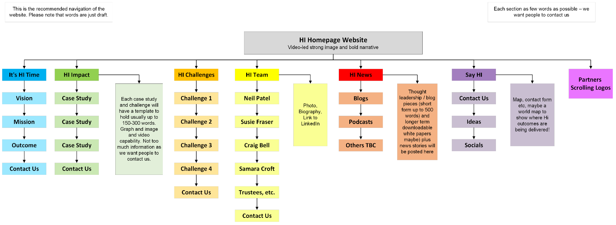

1. **Content Creation**

We are working closely with third party suppliers to also deliver outstanding content creation for this website including animations and video content, as well as photography. Our aim is that all the content will be ready to deliver the website build team no later than w/c September 25th. The content is also outlined within the navigation graph above. Further to that will be company information; privacy policies; cookie policies and other essential Governance documentation which will sit at the bottom of the website.

1. **Details & Fees**

* Proposals to be sent to Project Innovation no later than August 3rd, 2023, at 17.00.
* The chosen provider will be notified on August 7th and contract issued that week.
* Please note that, as we are part of the Glasgow Children’s Hospital Charity group and we, as a Not-For-Profit organisation, ask that budget efficiency should be maximised wherever possible, as well as in-kind support from key partners, suppliers and other businesses should be sourced where possible. ..

1. **Requirements & Evaluation**

You can submit your proposal in any format you wish.

Please provide: 

* Scope of work and working methods, with timelines
* Your interpretation of the key deliverables required
* Finance process
* Design costs and development costs separately
* Hosting and recommended SLA costs
* Team structure and biographies

ChildrHospitalCharity.org

1. **Timelines**

Please return your acceptance that you would like to tender to Susie Fraser by no later than close of business on July 28th at 17.00. We require your proposals by August 3rd, 2023, at 17.00.

[Susie.Fraser@gchcinnovation.org](mailto:Susie.Fraser@gchcinnovation.org)  **Tel: 07768 768 246**

Please send any questions relating to this tender to Susie Fraser no later than July 24th at midday. All questions and answers will be shared with all parties tendering.